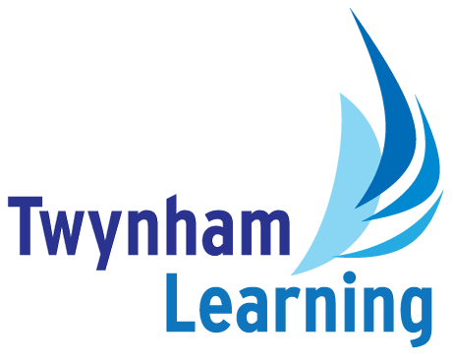**Job Description: Midday Supervisor**

|  |  |
| --- | --- |
| **Post Details** |  |
| **School/setting:** | Twynham Primary School |
| **Post type:** | Support Staff |
| **Grade/Pay Level:** | Grade 1 |
| **Weeks per year:** | Term time only |
| **Responsible to:** | Headteacher |

|  |
| --- |
| **Main Purpose** |
| To ensure the safety, general welfare and conduct of pupils during the midday break period.  Assistance is also given to school and catering staff with basic cleaning and general duties in and around dining areas. |

|  |
| --- |
| **Duties and Responsibilities** |
| * To supervise pupils in designated areas of the school during the midday break and to ensure their safety, welfare and general conduct through appropriate application of the school's policies and procedures. * To establish safe and appropriate behaviour by effective intervention or referral to senior staff. * To supervise the movement of pupils to and from dining areas, including any personal hygiene requirements. * To maintain good order in dining areas. * To assist pupils, where necessary, with the collection of food and return of trays, or other items to the service counter. * To assist pupils, where necessary, with the proper use of cutlery, drinking facilities or other aspects of the midday meal. * To assist in the clearance of any spillages and wiping down, clearing or resetting of tables, as appropriate. * To assist in the setting up and removal of furniture where necessary. * To take any immediate action to attend to sickness or accidents by carrying out minor first aid and summoning relevant assistance. * To report any unauthorised visitors on school premises. * To complete any documentation required by the school in relation to incidents occurring during the lunchtime break period and to participate in review meetings, as required. |

|  |
| --- |
| **Safeguarding Duties and Responsibilities** |
| * Promoting and safeguarding the welfare of children and young people in accordance with the school’s Safeguarding and Child Protection policies. |

|  |  |
| --- | --- |
| **Twynham Learning Attributes for all Staff** | |
| * Ambition for excellence * Professionalism * Humility * Championing change | * Inclusiveness * Positivity * Community-mindedness * Being collaborative |

|  |
| --- |
| **Personal Attributes** |
| **Essential:**   * No formal qualifications or previous experience is required but the ability to establish positive expectations of pupil behaviour, good relationships with staff and pupils, and a sensitivity to pupils' personal needs is important. * Manual handling of children’s lunch tables and chair etc * Necessary training in food handling may be required. * The postholder will be expected to work with limited supervision to an established work pattern. * To work as a co-operative member of a team * Ability to respond to challenging behaviour of pupils * Good communication skills * A calm, patient manner |

|  |
| --- |
| **Other Duties** |
| All Twynham Learning staff may periodically be expected to carry out tasks and duties within their area of competence that are not listed herein, as directed, to meet the needs of the Trust. The particular duties and responsibilities may vary from time to time. |

|  |
| --- |
| **Notes** |
| * This job description may be amended at any time in consultation with the postholder. |

|  |  |
| --- | --- |
| **Key to Acronyms Used/Glossary of Terms Used in this Job Description** | |
|  |  |