

Applicant Information Pack

Breakfast Club Supervisor

Permanent

10.5 hours per week

Contents

1. Our Schools
2. The local and surrounding area
3. Person Specification
4. Job Description
5. Appointment and Remuneration
6. Recruitment Privacy Notice



**1** **Our Schools**

Wyke Regis Primary Federation was established in September 2010 bringing together Wyke Regis Infant School and Nursery and Wyke Regis CE Junior School under one Governing Body. The schools are located on adjacent sites with generous and attractive grounds.

As a Federation, the schools have one Head of Federation, one Deputy Head of Federation, one Inclusion Manager and one Governing Body. Each school also has a non-teaching Assistant Head and a School Business Manager.

**Wyke Regis**

**Infant School and Nursery**

The school is a Community Infant School and caters for children aged between 3 and 7 years age.

The school’s nursery class offers part time nursery education. There are places for up to 26 children at each session. Currently each child can attend for up to 15 or 30 hours free a week, depending on whether they qualify for the extra hours of Government funding. The nursery is a self-contained unit with its own entrance, a large classroom, a kitchen area, toilets and a secure outdoor play area.

The school is a 2 form entry school, with an admission number (PAN) of 240. Each class base has a classroom, an annexe for small group activities, and a large art and craft area.

All classes have an outside learning area as well as sharing extensive grassed and hard surface play areas. The school’s accommodation also includes a large hall, library area and a Nurture Room.

The school is organised into 3 year groups with three year leaders forming our MLT.

Current Ofsted grade Good March 2020.

**Wyke Regis**

**CE Junior School**

The school caters for children aged between 7 to 11 years of age. The premises consist of twelve classrooms, a library, a large practical/resource area, a fully equipped ICT suite, a hall, with adjoining drama/music studio and three Learning Bases.

There are two play areas used for playtimes, including a sports MUGA and there is a large playing field for sporting activities.

As a Church of England Voluntary Controlled school, the school has close links with All Saints Church which is the parish church.

The school is a 3 form entry school with the majority of children progressing from Wyke Regis Infant School. The Junior School is also above average in size with an admission number (PAN) of 360.

The school is organised into 4 year groups, with 3 classes in each year group. Each year group is currently led by a Year Leader. Year Leaders have responsibility for pastoral care and the organisation of curriculum within their year group and form our MLT.

Current Ofsted grade Good March 2022.

3. The Area

1. THE COUNTY OF DORSET

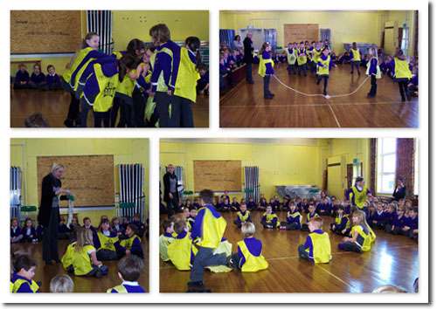

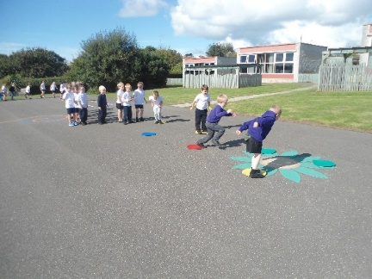

**2 The local and surrounding area**

The Federation schools are located in the village of Wyke Regis, part of the south western suburbs of Weymouth, on the northern shore of Portland Harbour, where the National Sailing Academy (host of the 2012 Olympic sailing events) is located and at the south eastern end of the world famous Jurassic Coast.

**POPULATION STATISTICS**

Dorset stretches from Lyme Regis in the west to Christchurch in the east and as far north as Sherborne and Gillingham. The greater part of the county is rural with many small villages and a few small towns. After Bournemouth and Poole, Weymouth is the largest settlement in Dorset. The most recent data records the County population at 754,460. The latest population for the Borough of Weymouth and Portland is recorded as 65,130 of which 16.5% are aged 0–15 years.

**THE AREA**

Wyke Regis has its own charter, granted in 988, and is proud of its history and present growth. It is a close community and, although spreading outwards, the ethos of the area is much determined by the Old Village at its centre.

**THE COMMUNITY**

The Federation Friends Association organise regular functions for pupils and members of the community. In addition, parents are encouraged to be actively involved within the Federation schools. The children are considered to have an important part to play in the running of the school. Each school has a School Council, which has taken a leading role in the school improvement process.

We work collaboratively with other local primary schools; links are also well established in the wider local community with the schools taking part in many events and festivals.

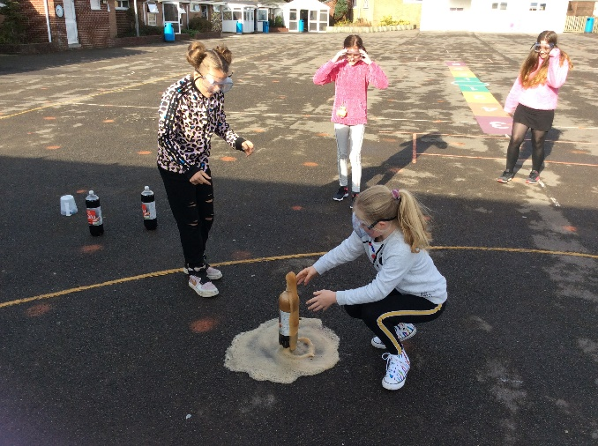

**3 Person Specification – Childcare Supervisor**

|  |  |  |
| --- | --- | --- |
| **Qualifications**  1. None | **Essential** | **Desirable** |
| **Experience**  2. Working with or caring for children of relevant age. | 🗸 |  |
| **Knowledge**  3. Understanding of relevant policies/codes of practice and awareness of relevant legislation.  4. Commitment to and understanding of equality of opportunity.  5. Basic understanding of child development and learning.  6. Basic food hygiene.  7. Appropriate knowledge of first aid.  8. Basic health and safety. | 🗸  🗸  🗸 | 🗸  🗸  🗸 |
| **Skills**  9. Confidence in dealing with children, maintaining discipline, motivation and ensuring well-being of children.  10. Work constructively as the leader of a team.  11. Ability to maintain registers and administer the booking system.  12. Ability to maintain confidentiality at all times.  13. Ability to maintain positive relationships with staff and parents/carers.  14. Display commitment to the protection and safeguarding of children. | 🗸  🗸  🗸  🗸  🗸  🗸 |  |

**4**  **Job Description for Childcare Supervisor**

**Purpose of the Post**

* To supervise the team supervising the children attending the Federation’s Breakfast Club.

**Main Duties and Responsibilities**

Support for Pupils

* Supervise children in collecting food and drink, being seated, clearing away crockery and cutlery and moving to activities indoor and outdoors.
* Organise play activities.
* Establish good relationships with children; interact positively with children, encouraging co-operation and mutual support.
* Monitor children’s well-being and readiness for class; provide help and support to children.
* Encourage good behaviour by using praise and reward and taking action with poor behaviour in line with federation policy.
* Ensure the health and safety of children.
* Take pride in providing an enjoyable breakfast and activities for pupils.
* Consider the needs of children when making decisions about the club.
* Anticipate pupils’ needs and make suggestions to support them.

Support for the School

* Prepare the Breakfast Club facilities and activities, ensuring the quality standards agreed are met.
* Support and develop the team, encouraging staff to contribute to the overall ethos of the Federation. Reflect with the team on successes and issues of concern.
* Induct new staff in policies, procedures and act as part of the team. Cover absences and co-ordinate pupil bookings.
* Maintain parent/carer contact details and a register of children attending.
* Control access to other areas of the school, administer any necessary basic first aid, record all injuries and ensure staff and children understand action to be taken in case of fire.
* Attend regular meetings and training.
* Acknowledge all colleagues in a friendly and helpful way.
* Build effective working relationships with others by being open and honest.
* Acknowledge the need for team working.
* Treat all colleagues in a courteous and helpful manner.
* Be aware of and comply with policies and procedures relating to safeguarding, health and safety, security, confidentiality and whistle blowing, reporting all concerns to an appropriate person.
* Be aware of and support difference and ensure all pupils have equal opportunities to participate, learn and develop.
* Monitor use of consumables and ensure that there is sufficient food to provide for attending pupils.
* Liaise with parents regarding any food intolerances/allergies and order food accordingly.
* Produce a weekly online shopping list for the office to organise. Check food delivery with order on arrival.

This is the description of the main duties and responsibilities of the post at the date of production. The duties may change over time as requirements and circumstances change. The person in the post may also have to carry out duties as may be necessary from time to time.

**General Requirements**

* Participate in the Federation’s performance management system.
* Attend meetings with the Head of Federation on a regular basis.
* Enhanced DBS check.
* Strong commitment to further equality of opportunity.
* Promote and safeguard the welfare of children that you are responsible for or come into contact with.

**DORSET COUNCIL JOB DESCRIPTION**

CHILDCARE SUPERVISOR

|  |  |  |  |  |
| --- | --- | --- | --- | --- |
| **Job title**: | Childcare Supervisor | | **Job Ref**: | CC3.10 |
|  | | | | |
| **Directorate:** | |  | | |
|  | | | | |
|  |  | | **Grade**: | Dorset Grade 6 |
|  | | | | |
| **Reports to**: | Headteacher/Day Care Management Committee | | | |

|  |
| --- |
| **Main job purpose** |

To be responsible for the day to day running of a small sized childcare provision.

|  |
| --- |
| **Main responsibilities and duties** |

1. To plan the curriculum to maximise the development of each child.
2. To prepare activities and organise resources for each session.
3. To be involved in the development of other staff, including training, assessment, monitoring and supervision.
4. To lead the team in offering high quality childcare provision, and attend meetings as appropriate
5. To plan and deliver a curriculum, which leads towards the meeting of agreed objectives and targets.
6. Keep records as appropriate.
7. Be responsible for the care, presentation, display, safety, organisation and appearance of the facilities and equipment.
8. Be committed to the principles of equality of opportunity for all.
9. Read, discuss, understand and implement all policies.
10. Encourage parental involvement and maintain confidentiality.
11. Promoting and safeguarding the welfare of children and young people in accordance with the school’s safeguarding and child protection policy.

|  |
| --- |
| **Knowledge & skills** |

To hold a Level 3 qualification in Childcare.

To be committed to undertaking further training or development as required.

Have a detailed understanding of child development and relevant experience of working with children.

Be able to act under own initiative and to make decisions.

To have the ability to establish good relationships with children, parents and other staff, communicating clearly and sensitively.

To relate well to children and adults and work co-operatively with the staff team and with parents to share knowledge and expertise for the benefit of the children.

To be aware of the need for confidentiality.

Be aware of the management systems in place for the provision of childcare and have the ability to liaise effectively with the Headteacher of the school and / or the Management Committee.

|  |
| --- |
| **Supervision and management** |

Typically there will be supervision available from the Headteacher or Management Committee on a regular basis.

The post holder will be required to support the induction and further training staff employed within the child care provision.

|  |
| --- |
| **Problem solving and creativity** |

On a daily basis, adapt activities for individuals and groups of children.

Use a variety of techniques to establish supportive relationships with children, parents and carers.

A creative approach to supervisory duties, training and supporting staff is required.

|  |
| --- |
| **Key contacts and relationships** |

Contact with staff to pass and receive information, advice, guidance, suggestions and ideas.

Contact with professionals to provide daily support for pupils with known medical conditions.

Contact with parents / carers and other agency staff to provide support for children, such as giving feedback on children’s individual needs.

|  |
| --- |
| **Decision making** |

Within agreed policies, guidelines and rules, decide on when and how to apply a range of strategies for the benefit of children in relation to their education activities, behaviour and care. These decisions often need to be made immediately to deal with the situation presented.

There will often be a need to make immediate decisions, without initial referral to the Headteacher or Management Committee, in relation to immediate care, control and safety of children.

|  |
| --- |
| **Resources** |

Books, stationary, writing equipment.

ICT and AVA equipment.

|  |
| --- |
| **Working Environment** |

Part of the working day is spent standing, with periods of crouching / bending to engage pupils in activities.

There may be occasional need to physically lift children, such as for safety or care needs and occasional unpleasant conditions relating to childrens‘ personal hygiene needs.

|  |  |
| --- | --- |
| **Job description prepared by:** |  |
|  | |
| **Designation:** |  |
|  | |
| **Date:** |  |

**5**  **Appointment and Remuneration**

**How to Apply**

Your completed application form must be submitted by the submission date. Interviews will be held following the shortlisting process and candidates will be informed by telephone and e-mail. Your supporting statement should detail your motivation for applying for this position. Decisions regarding the short-list will be made with reference to the person specification and job description.

NB: All applicants are required to complete the Dorset Council application form. We do not accept CVs in place of an application form.

**Selection Process**

The selection process will be undertaken by the Wyke Regis Primary Federation Senior Leadership Team (SLT) who are committed to selecting excellent and motivated individuals to become part of our outstanding team to take our Federation forward.

If you require any more information please contact Mrs Wanda Roberts, Head of Federation.

Any offer of employment made will be subject to receipt of satisfactory references, and positive responses to other pre-employment checks regarding your suitability for appointment.

Further details of the recruitment process and our Information Management and Data Protection procedures are contained in Recruitment Privacy Notice overleaf.

**Salary**

The salary for this position will be NJC Grade 6 Scale points 6-9 and will be commensurate with experience.

website: www.wykeregisfed.dorset.sch.uk

**6 Recruitment Privacy Notice**

Wyke Regis Infant School and Nursery and Wyke Regis CE Junior School (collectively referred to as Wyke Regis Primary Federation) are the data controllers for the information you provide during the recruitment and selection process unless otherwise stated.

**What will we do with the information you provide to us?**

The information you provide during the process will only be used for the purpose of progressing your application, or to fulfil legal or regulatory requirements.

We will not share any of the information you provide during the recruitment and selection process with any third parties or store any of your information outside of the European Economic Area. The information you provide will be held securely by us and/or our data processors whether the information is in electronic or physical format.

We will use the contact details you provide to us to contact you to progress your application. We will use the other information you provide to assess your suitability for the role you have applied for.

**What information do we ask for, and why?**

We do not collect more information than we need to fulfil our stated purposes and will not retain it for longer than it is needed.

The information we ask for is used to assess your suitability for employment. You don’t have to provide what we ask for but it might affect your application if you don’t.

**Application stage**

We ask you for your personal details including name and contact details. We will also ask you about your previous experience, education, referees and for answers to questions relevant to the role you have applied for.

You will also be asked to provide equal opportunities information. This is not mandatory information – if you don’t provide it, it will not affect your application. Any information provided during the online application process is not provided to the school. Any information you do provide, will be provided to and used by Dorset Council only to produce and monitor equal opportunities statistics.

**Conditional offer**

If a conditional offer of employment is made to you, we will ask you for information so that we can continue our pre-employment checks. You must successfully complete pre-employment checks to progress to a final offer.

We are required to confirm the identity of our staff, their right to work in the United Kingdom and seek assurance as to their trustworthiness, integrity and reliability.

You will therefore be required to provide:

* Proof of your identity – you will be asked to present original documents, which we will photocopy.
* Proof of your qualifications – you will be asked to present original documents, which we will photocopy.
* You will be asked to complete a criminal records declaration (Form HR14) to declare any unspent convictions.

The email address you provide will be used by the employing school to contact you to complete an application for a Criminal Record check via the Disclosure and Barring Service.

We will contact your referees, using the details you provide in your application, directly to obtain references.

**Occupational Health**

If we make you a conditional offer, we will ask that you complete a questionnaire which will help to determine if you are fit to undertake the work that you have been offered, or advise us if any adjustments are needed to the work environment or systems so that you may work effectively.

Should further consideration be required regarding your fitness for work, you may be asked to complete a pre-employment questionnaire. The information you provide will be forwarded unopened to Dorset Council’s Occupational Health Team who will provide us with a fit to work certificate or a report with recommendations. You are able to request to see the report before it is sent to us. If you decline for us to see it, then this could affect your job offer. If an occupational health assessment is required, this is likely to be carried out by Dorset Council’s Occupational Health Team or on occasion OH Assist, the County Council’s external occupational health specialists.

Their privacy notice can be viewed at: <http://www.ohassist.com/privacy-policy/>

Once all pre-employment checks have been satisfactorily completed and we make a final offer of employment, we will also ask you for the following:

Bank details – to process salary payments

Emergency contact details (NoK) so we know who to contact in case you have an emergency at work

**Personnel Records**

If you accept the final offer from us, your electronic personnel records will be held on SIMS, Dorset Council’s approved Management Information System provided under licence by Capita plc.

Your personnel records will also be held on SAP which is the records system used by Dorset Council Human Resources Department on our behalf for the purposes of payroll and the retention of data about your employment.

Their privacy notice can be review at:

[https://www.sap.com/corporate/en/legal/**privacy**.html](https://www.sap.com/corporate/en/legal/privacy.html)

**Retention of Information**

If you are successful, the information you provide during the application process will be retained by the school as part of your employee file for the duration of your employment plus 6 years following the end of your employment.

If you are unsuccessful at any stage of the process, the information you have provided until that point will be retained for 6 months from the closure of the recruitment and selection process.

Information generated throughout the assessment process, for example interview notes, is retained by us for 6 months following the closure of the recruitment and selection process.

Equal opportunities information is retained for 6 months following the closure of the recruitment and selection process whether you are successful or not.

**Your rights**

Under the General Data Protection Regulation, you have rights as an individual which you can exercise in relation to the information we hold about you.

You can read more about these rights here –

<https://ico.org.uk/for-the-public/is-my-information-being-handled-correctly/>

**Complaints or queries**

Wyke Regis Primary Federation tries to meet the highest standards when collecting and using personal information. For this reason, we take any complaints we receive about this very seriously.

We encourage people to bring it to our attention if they think that our collection or use of information is unfair, misleading or inappropriate. We would also welcome any suggestions for improving our procedures.

This privacy notice was drafted with brevity and clarity in mind. It does not provide exhaustive detail of all aspects of the Federation’s collection and use of personal information.

However, we are happy to provide any additional information or explanation needed. Any requests for this should be sent to the address below.

If you want to make a complaint about the way we have processed your personal information, you can contact the Data Controller at the school concerned:

|  |
| --- |
| Wyke Regis Infant School and Nursery  Shrubbery Lane  Wyke Regis  Weymouth  Dorset  DT4 9LU |

**Access to personal information**

Wyke Regis Primary Federation tries to be as open as it can be in terms of giving people access to their personal information. Individuals can find out if we hold any personal information by making a ‘subject access request’ under the Data Protection Act 1998 and General Data Protection Regulations.

If we do hold information about you, we will:

give you a description of it;

tell you why we are holding it;

tell you who it could be disclosed to; and

let you have a copy of the information in an intelligible form.

To make a request for any personal information we may hold you need to put the request in writing addressing it to our Data Controller or writing to the address provided above.

If you agree, we will try to deal with your request informally, for example by providing you with the specific information you need over the telephone.

If we do hold information about you, you can ask us to correct any mistakes by, once again, contacting the Data Controller at the school.



